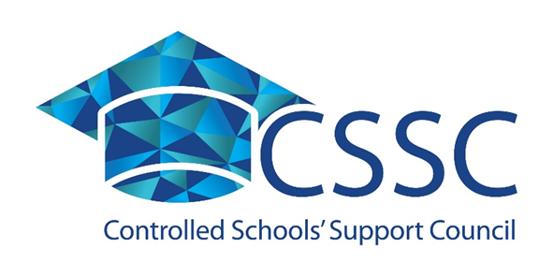

An analysis of the controlled education sector in Northern Ireland

Rachel McMenemy
Research and Insights Officer
Email: Rachel.mcmenemy@csscni.org.uk
Tel: 02890 313 046
May 2017
What is the controlled schools’ sector?
The controlled schools’ sector is one of five sectors which make up the Northern Ireland education system. It is largest sector, providing education through 560 schools for over 140,600 pupils, yet it is largely misconstrued.
This paper aims to provide a clearer picture of the controlled sector and challenge many of the misconceptions surrounding its operation and enrolment.
Contents

1. History 2
2. Context – Education in Northern Ireland 3
3. Key facts and figures 5
a. The controlled sector is large 5
b. The controlled sector is diverse 6
c. The controlled sector is inclusive 7
4. Summary - Supporting the controlled sector 10

History
The origins of the controlled sector began in the early 20th century, when schools managed mainly by the Protestant churches were transferred to the state.
Together with schools provided directly by the state, they formed a non-denominational, church-related sector delivering free education for all children irrespective of background.
From these beginnings of a historic faith context and a commitment to free public education, today's controlled schools provide for a more pluralist society through a diversity of schools with individual characteristics, but with core values and principles.
Today the controlled sector is the largest of the five education sectors in Northern Ireland. Unlike its counterparts, it was unrepresented for over thirty years, contributing to the lack of understanding and number of commonly held misconceptions about the sector.
The Education Act (Northern Ireland) 2014 provided for the establishment of a body representing the interests of controlled schools.
In September 2016 the Controlled Schools’ Support Council (CSSC) was launched to represent and support the sector.

CSSC is a non-statutory body, currently classified as a non-profit institution and part of the private sector. It is funded by the Department of Education (DE) but may seek funding for specific projects from other sources.

Education in Northern Ireland
The Northern Ireland education system is complex, with a range of organisations involved in administering and providing education.
The table below provides an overview of the five school sectors in Northern Ireland.
Table 1 - Education sectors in Northern Ireland
Sector | % of Schools | Summary | Support body
Controlled | 48.4% | Schools are managed and funded by the Education Authority (EA) through Boards of Governors. Primary and post-primary school Boards of Governors consist of representatives of transferors, representatives of parents, teachers and the EA.  EA is also the employing authority for controlled schools. | Controlled Schools’ Support Council (established September 2016)
Catholic Maintained | 40.3% | The Employing Authority is the Council for Catholic Maintained Schools (CCMS). Schools are managed by Boards of Governors which consist of members nominated by trustees, along with representatives of parents, teachers and the EA. | Catholic Council for Maintained Schools (CCMS) (established 1989)
Voluntary | 5.3% | Self-governing schools, funded by the Department and managed by Boards of Governors. The Boards of Governors are constituted in accordance with each school's scheme of management - usually representatives of foundation governors, parents, teachers and in most cases, DE or EA representatives.  The Board of Governors is the employing authority and is responsible for the employment of all staff in its school. | Governing Bodies Association NI (GBA) (Established c. 1940)
Grant Maintained Integrated | 3.3% | Self-governing schools with integrated education status, funded directly by the Department of Education and managed by Boards of Governors. The Board of Governors is the employing authority and responsible for employing staff. | Northern Ireland Council for Integrated Education (NICIE) (Established 1989)
Other Maintained | 2.7% | Mostly-Irish Maintained schools. DE has a responsibility to encourage and facilitate Irish-Medium Education. | Comhairle na Gaelscolaíochta (established 2000)

Key facts and figures
This section provides an overview of the controlled sector, based on data gathered from the Department of Education.

The controlled sector is large
There are 560 schools in the controlled sector, accounting for 48% of all schools.
Table 2 - Schools and Pupils by sector (2016/2017)
 | Northern Ireland | Controlled | Catholic Maintained | Grant Maintained Integrated | Voluntary | Other maintained
Schools | 1156 Schools | 560 schools (48.4%) | 466 schools (40.3%) | 38 schools  (3.3%) | 61 schools (5.3%) | 31 schools (2.7%)
Pupils | 332986 pupils | 140,632 pupils  (42%) | 121,733 pupils  (37%) | 15,907 pupils (5%) | 50,332 pupils  (15%) | 4382 pupils  (1%)

The controlled sector caters for over 140,600 pupils and employs over 8,500 teachers.
The controlled sector is the largest education sector in Northern Ireland.
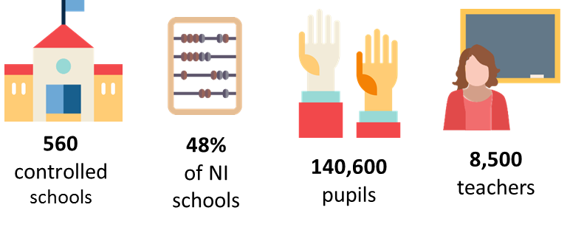

The controlled sector is diverse
The sector is made up of a range of school types – nursery, primary, post primary (secondary and grammar) and special schools. It is the only sector to contain all school types.
Table 3 - School types by sector in Northern Ireland
Sector | Nursery | Primary | Post primary |  | Special
 |  |  | Secondary | Grammar
Controlled

Catholic Maintained

Grant Maintained Integrated
Voluntary

Other Maintained

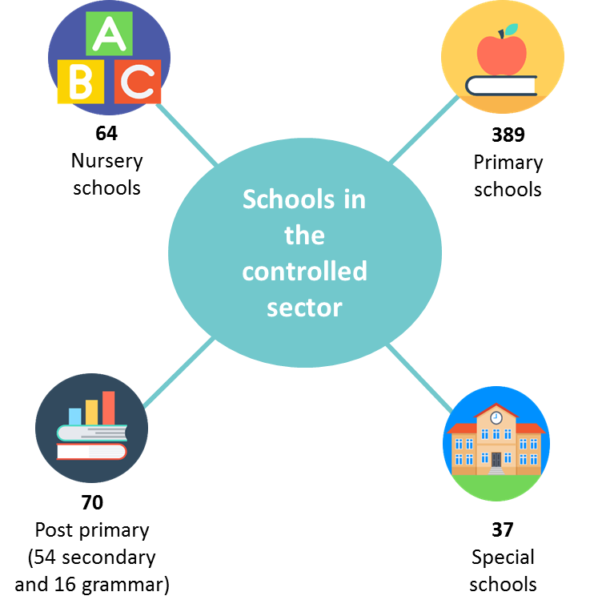
Figure 2 - Schools in the controlled sector (2016/2017)

The majority of nursery schools, primary schools and special schools in Northern Ireland are controlled. In particular, 95% of all special schools belong to the controlled sector.
The controlled sector also includes 27 integrated schools and two Irish medium schools.
2
Irish-medium schools
27
Integrated controlled schools

The controlled sector is inclusive
- Religion - The sector provides education for children of all faiths and none.

The following is a breakdown of controlled pupils by religion.
Figure 3 - Pupils in controlled schools by religion (2016/2017)

Many people equate the controlled sector with the ‘Protestant sector’, however although the majority of pupils are Protestant (66%), the proportion is not as high as common perception may suggest. Controlled schools welcome pupils from all faiths and none and this is reflected in the religious breakdown detailed above. Over the last decade (2006/07 - 2016/17) the percentage of Protestant pupils in controlled schools has decreased by 10.2% (from 76.4% to 66.2%).
The chart below provides a breakdown for each of the five education sectors in Northern Ireland.
Figure 4 - Religion of pupils attending Northern Ireland schools by sector (2016/17)

The Grant Maintained Integrated (GMI) sector is by definition the most diverse sector with the intention of taking a balanced intake across schools. In both the Other Maintained and Catholic Maintained sectors a high proportion of their overall enrolment is from Catholic pupils (84% and 96% respectively). The controlled sector has greater religious diversity by comparison and, interestingly, provides education for more pupils of no religion than any other sector.

- Newcomer pupils - Over a third of newcomer pupils in Northern Ireland attend controlled schools.
Almost half of controlled primary schools have between 1-10% newcomer pupils as a proportion of their total enrolment.
In 49% of controlled primary schools between 1-10% of pupils are newcomer pupils
1/3 of newcomer pupils

- Free school meals - free school meal entitlement is the main measure of deprivation used in education statistics.
31% of all controlled pupils are entitled to free school meals

At post primary level secondary schools have much higher proportions of pupils entitled to free school meals compared to grammar schools. Only 6% of grammar schools have more than 30% of pupils entitled to free school meals, compared to 67% of secondary schools.

The majority of schools have a proportion of between 10-30% of pupils entitled to free school meals. The following map shows the location of controlled schools with over 50% of pupils entitled to free school meals.
Figure 5 - Controlled schools with 50% or more pupils entitled to free school meals

The majority of these schools are located in the Belfast area, with some schools having very high proportions of free school meal entitled pupils.
- Special educational needs - Over 28,700 primary and post-primary pupils have special educational needs (SEN).
Post-primary level
1/3 of SEN pupils attend controlled schools
Primary level
49% of SEN pupils attend controlled schools

At post-primary level it is noticeable that the schools with higher proportions of SEN pupils are secondary schools as opposed to grammar schools. For example, 30% of secondary school pupils have SEN, compared to 7% of grammar school pupils.

Summary - supporting the controlled sector
For many years the controlled sector has been misconstrued and unrepresented. For the first time in over thirty years the sector has a representative voice through the Controlled Schools’ Support Council (CSSC).
The controlled sector is the largest education sector in Northern Ireland and has many strengths which must be recognised and celebrated. A rich diversity is evident in the controlled sector, providing education through each of the school types. It is also widely inclusive and welcomes children from all backgrounds and circumstances.
The sector strives to give each child with the opportunity to thrive. CSSC will seek to enhance the quality of educational provision within the controlled sector with a focus on advocacy, ethos, governance and raising standards.
CSSC has already begun to engage directly with schools, to provide support where it is needed most, for example in area planning and with bids for funding. A research programme will look at how educational achievement can be further enhanced and good practice will be shared. The goal will be to support controlled schools and ensure the interests of children are foremost.

Through the School Census – 2016/2017 data.
All icons from FlatIcon.
The category ‘other’ includes ‘other Christian’, ‘non-Christian’ and ‘undisclosed’.
The term 'newcomer' is used to refer a pupil who does not have satisfactory language skills to participate fully in the school curriculum and does not have a language in common with the teacher.

