Social Media Survey 2016

Key Results
The Northern Ireland Local Government Commissioner for Standards undertook a survey of councillors’ use of social media in November 2016. Seventy-five councillors completed the survey. Councillors’ responses to each of the 21 survey questions are provided in the diagrams below. The key results emerging from the survey are as follows:
- Facebook is the social media site most used by councillors (70 of the councillors responding to the survey question had used it in the past year). Twitter was the second most popular site (54 out of 70 councillors responding has used it in the previous year).

- On social media sites most councillors identify themselves as a councillor (92% of those responding).

- The majority of councillors access social media on devices provided by their Council (59% of those responding).

- Most Councillors use social media in the evening or at weekends (55% of respondents).

- Over a quarter of councillors (27% of respondents) did not know if their Council had a policy on members’ use of social media.

- The majority of councillors responding (61%) had been subject to unfair or hostile comments on social media, mainly from members of the public.

- A fifth of councillors had posted comments online which they later regretted and a few (7% of respondents) had made a comment for which they had considered apologising.

- Councillors most often use social media to chat about their personal interests such as sport (22% of respondents), but also used it to provide general advice or information to constituents (20%), or to respond to the concerns of individual constituents (9%), or to promote community events (9%).

- Most councillors (74%) do not have separate social media accounts for their work as councillors.

- Over a quarter of councillors (27%) do not know how to restrict access to the social media sites they use and over half (57%) do not use any ‘privacy setting’ to restrict access to sites they use in their private life.

- Most councillors (80% of respondents) would welcome training on the use of social media in compliance with the Code of Conduct and the law. Many (43% of respondents) also wanted guidance on their personal safety and security online.

Q1. Have you posted any content (comments, or photos or video clips) to a social media site in the past 12 months? Social media sites include blogs, micro blogs (such as Twitter and Tumblr), internet forums, content communities (such as Youtube, Pinterest and Vine), messaging apps (such as Instagram, Snapchat or Whatsapp) and social networking sites (such as Facebook and LinkedIn)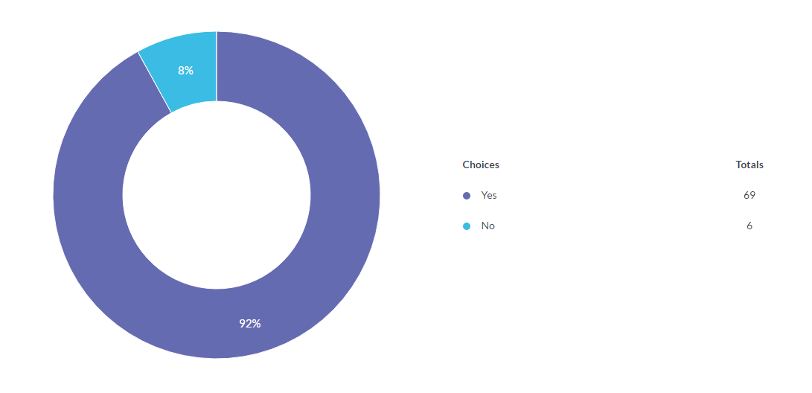

In total 75 participants answered this question, 6 answered no, 69 answered yes.

Q2. Tick the box (all that apply) if you have posted content or used any of the following social media sites in the last year.

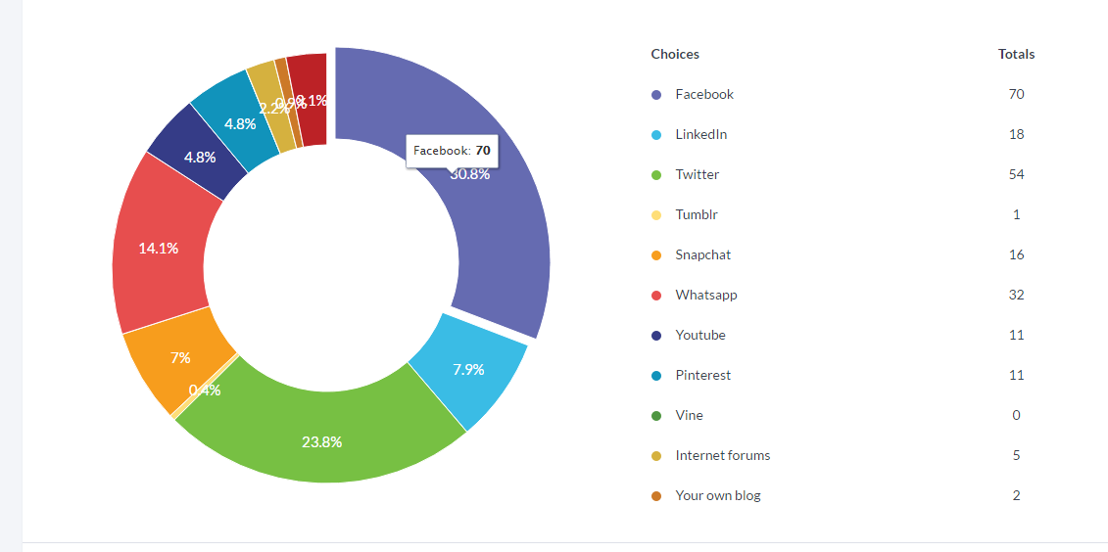

In total 70 participants answered this question, 5 participants did not answer this question. Facebook 70 , LinkedIn 18, Twitter 54, Tumblr 1, Snapchat 16, Whatsapp 32, Youtube 11, Pinterest 11, Vine 0, Internet forums 5, Your own blog 2, Other 7.

The ‘other’ sites include Spotify, NextDoor, Instagram, MyFitnessPal, MapMyWalk, Gumtree, BodySpace, Audible.

Q3. Tick the box to indicate if any of the social media sites you use identify you as a Councillor (either by title or indirectly because of the type of comments you make)

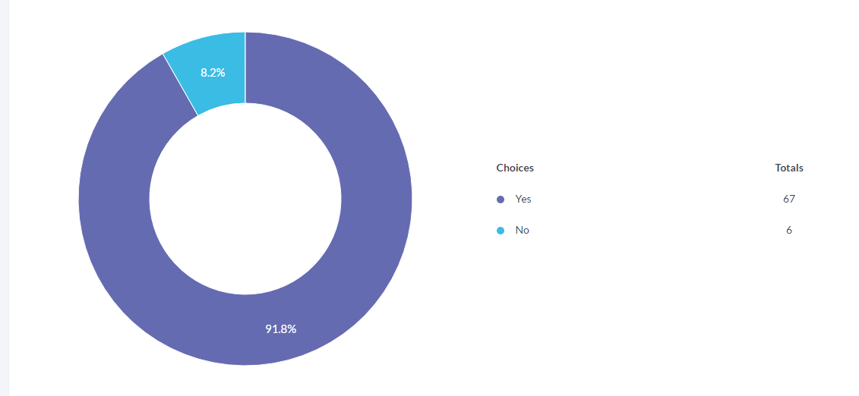

In total 73 participants answered this question, 2 participants did not answer this question.

Q4. Tick the box to indicate whether or not the device you use to access social media has been provided to you by your Council

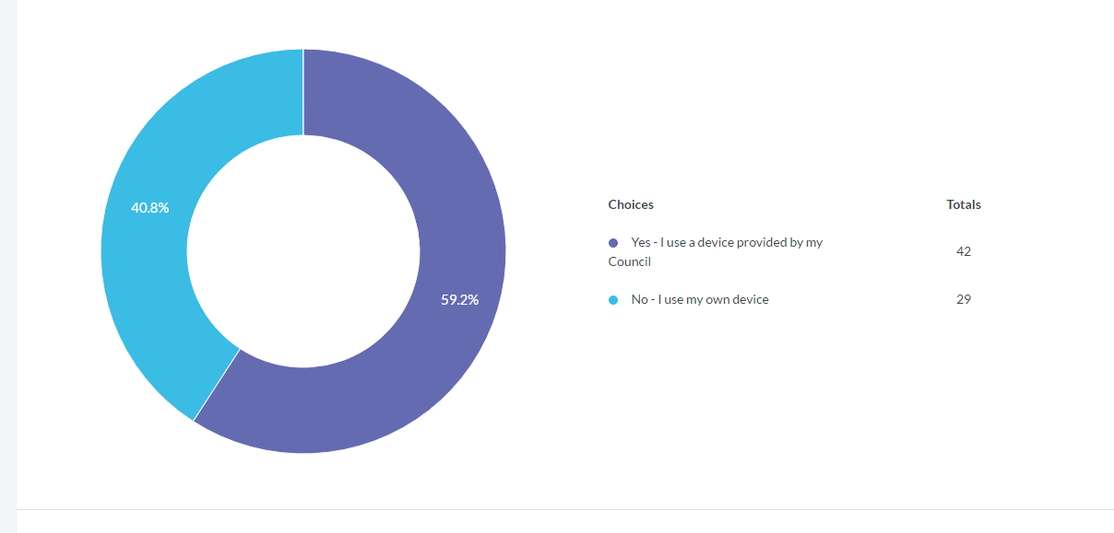

In total 71 participants answered this question, 4 participants did not answer this question.

Q5. What time of the day do you most often use social media?

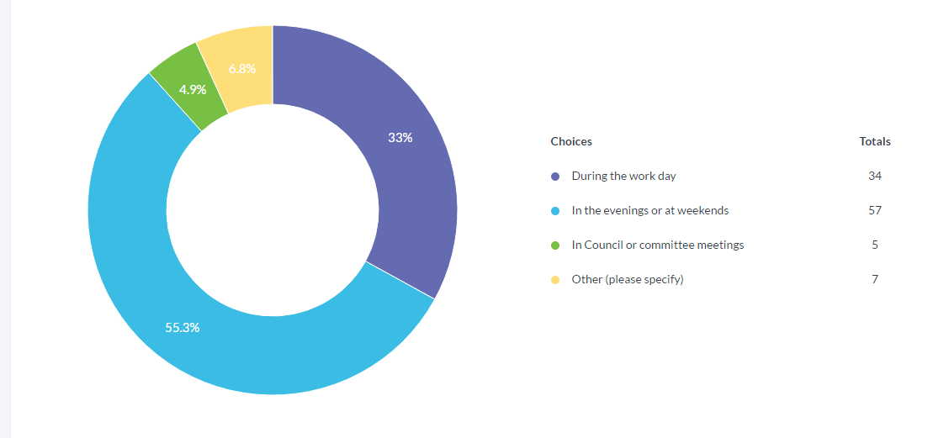

In total 72 participants answered this question, 3 participants did not answer this question.

Q6. Which of the following statements do you agree with?

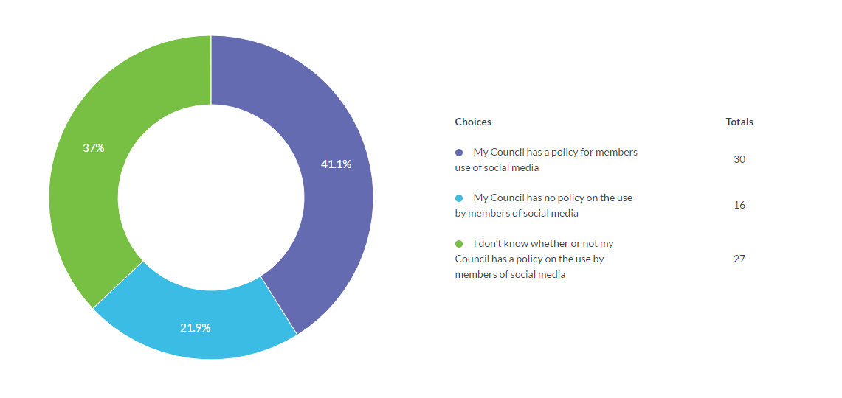

In total 75 participants answered this question, 2 participants did not answer this question.

Q7. Have you been subject to unfair or hostile comments on social media?

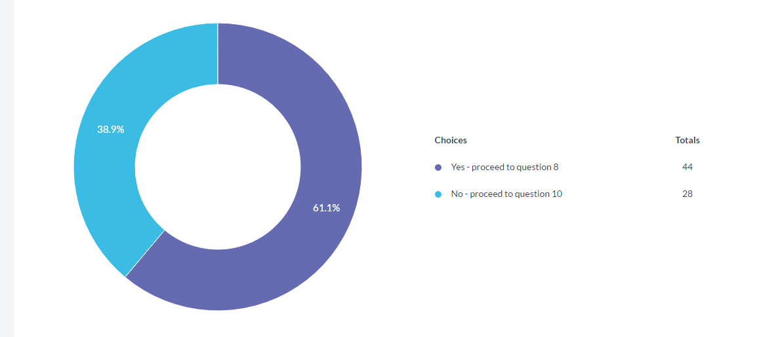

In total 72 participants answered this question, 3 participants did not answer this question.

Q8. If you have been subject to unfair or hostile comments, was the person who commented (tick all that apply)

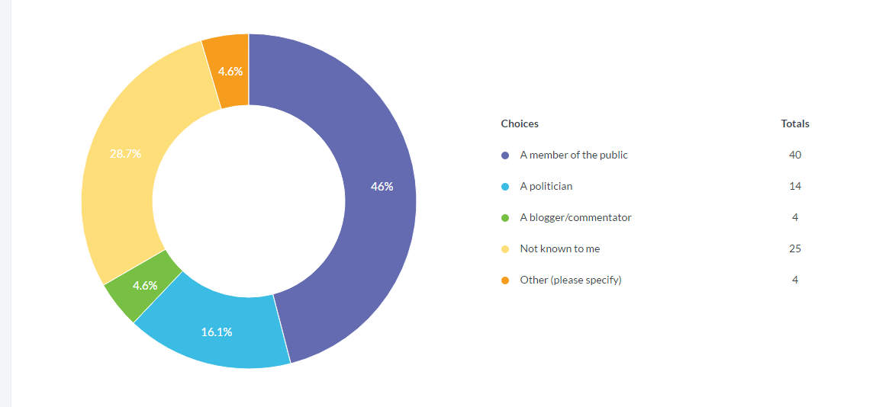

In total 48 participants answered this question, 27 participants did not answer this question.

Q9. Tell us more about how you responded to those online comments

  - Ignored them but later clarified the inaccuracies that they had mentioned in a new post of my own.
  - Remove them from access to me on the media
  - I never respond immediately to posts to give me time to reflect or check information without the other party realising I am doing it (just look busy).
  - Try to be rational and present the facts, the social media threads tend to snowball, where you could spend your weekend firefighting and representing yourself, party and council in engaging with the public.
  - I comment on fb that i would be happy to deal any issues my constituents might have. I spoke with the PSNI
  - Ignore or 'hide'
  - Mostly ignored
  - The nature of political life is that some people will simply dislike you having learnt that you belong to a political party they do not favour.
  - By deleting their comments, sometimes reporting to the social media site, at other times graciously responding. Some of the abuse has been vile in nature.
  - Ignored
  - I normally delete as I do not use social media to debate, I use the debating chamber for that. I use it to spread and receive information.
  - Ignore.
  - Did not respond
  - Some best left unanswered but have also come back with short reply
  - Gave the facts
  - not on f/b or any social media
  - I did not comment
  - I didn’t
  - In a calm and professional manner
  - I closed down the link between my Twitter and Facebook accounts, closed the ability for people to comment on Facebook and ceased using Facebook and blocked abusers on Twitter
  - Tend to ignore them
  - I ignored them.
  - Did not respond
  - I didn't respond
  - Either respond calmly, or if cursing has been used I will remove the comment and ask them to repost without profanity
  - Critical of political opinions.
  - I didn't respond as I thought it was best to put my side across in a newspaper article. That way, I wasn't being dragged into an online arguement, but was able to answer the criticisms about me.
  - Sometimes I engage with the users. if it appears there will be no dialogue and they are only there to cause offense I stop replying. I rarely block/delete though.
  - I don't - no response is the best method
  - I usually respond once to the comment, either explaining my position or calling the person out on the motive for their comment, if they continue to make comments I usually monitor it but not respond.
  - I pointed out party policy on the issue and clarified the facts.
  - I ignore commentary from fictional persons - if clearly it is a member of the public then I answer the concerns as best I can.
  - Persons were blocked
  - Generally did not respond if asked a question , made enquiries and passed on same
  - Ignored
  - Dismissed them politely & blocked them so they can't access my page or any future posts I make.
  - Earlier training told me not to respond.
  - In some instances, careful responses were made to address inaccuracies and others were simply deleted and I ignored the comments.
  - I didn't respond most times.
  - Defended my position in as diplomatic way as possible.
  - I was factual in my respond
  - Usually ignore them if they are not relevant to the thread. Sometimes challenge general comments like "you are all the same"
  - Matter referred to PSNI but no action taken
  - Any that were directly abusive I ignored, those that were harsh and critical but not abusive I engaged with - e.g.: responded with facts or clarifications
  - Just responded with facts

In total 48 participants answered this question, 27 participants did not answer this question.

Q.10 Have you received training from your Council, representative body or your party on any of the following?

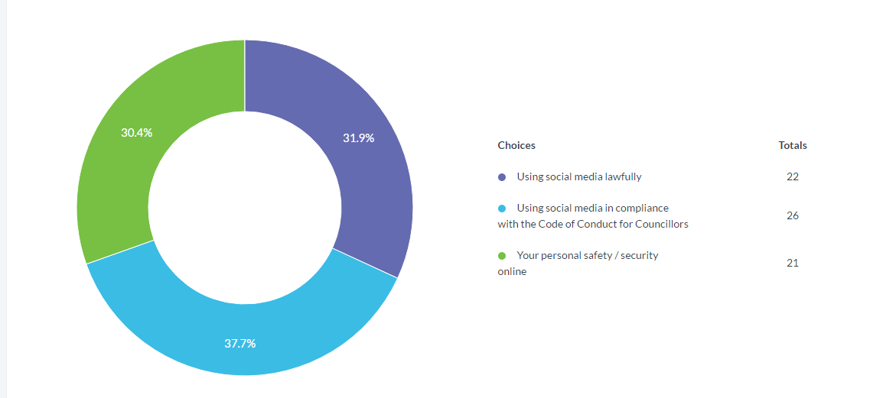

In total 39 participants answered this question, 36 participants did not answer this question.

Q.11 Would you welcome training on any of these courses?

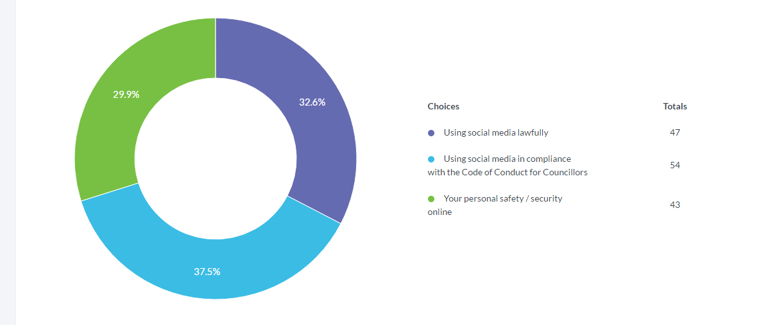

In total 60 participants answered this question, 15 participants did not answer this question.

Q.12 Have you posted a comment online which you later regretted?

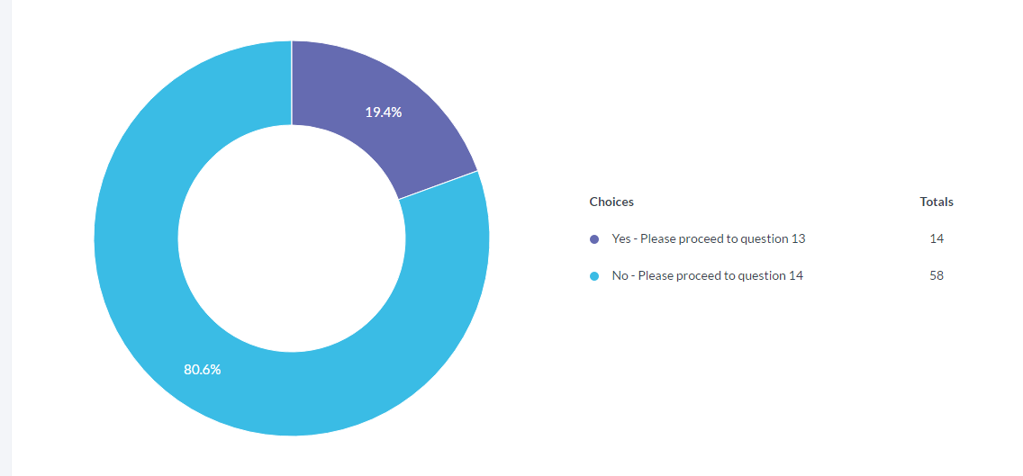

In total 72 participants answered this question, 3 participants did not answer this question.

Q.13 Tell us what you have learned from this experience
  - Measure twice cut once
  - I've very mindful not to post political comments as I work in the private sector and also because my family can be identified from my accounts so I only tend to engage in information sharing or constituent queries
  - Nothing that would cause me beaching the code but it has damaged relationships. I am more careful even when I think the post is a private message.
  - While I have received training I would like further training to be updated. Social media is the future for communication
  - That what you write can be misinterpreted
  - Don't post comments in the heat of the moment.
  - Sometimes trying to engage with people honestly simply leads to misunderstanding and can result in a protracted online to and fro exchange of views that might be better dealt with in a face to face meeting or telephone conversation.
  - Only in personal capacity of life
  - Avoid overly political controversial statements.
  - Social media should be handled carefully. If your not willing to put your post on the front page of a newspaper then don't post it online
  - Double check who can access the message.
  - I posted my snapchat username on twitter and instantly regretted it as individuals looking for an entirely different type of interaction added me, which taught me to be slightly wiser in how I advertise myself
  - Always double check what you're writing
  - People can manipulate part of a post and turn it around to mean something completely different to how it originally was intended.
  - Take time to respond
  - Nothing to regretful but the odd time I inadvertently open a can of worms when people take a different interpretation from what I intended.
  - To think or calm down before engaging.

In total 21 participants answered this question, 54 participants did not answer this question.

Q.14 Have you ever felt you should apologise for a comment you posted online?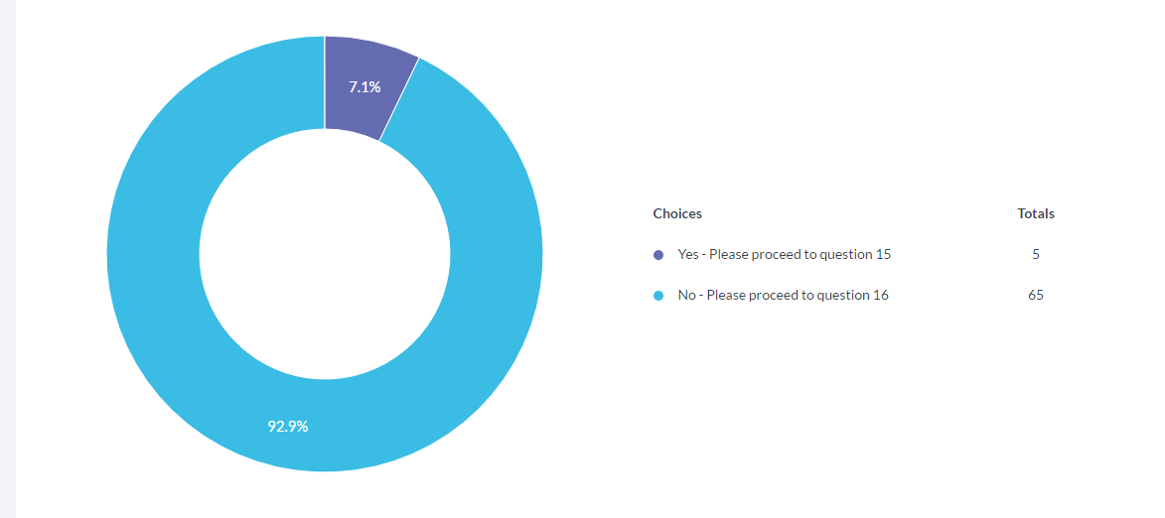

In total 70 participants answered this question, 5 participants did not answer this question.

Q.15 Tell us what you’ve learned from this experience
  - To not state things on social media in anger or haste
  - It wasn't something would be in breach of the code but It caused relational damage.
  - To be exceptionally sensitive even about issues which appear relatively neutral to me!
  - I think there is a need for training for councillors on social media
  - I've never had to apologise for an online comment.
  - Double check who can access the message.
  - Be careful in future
  - Think twice before posting, take a deep breath and go and make a cuppa before responding to something you dislike.

In total 11 participants answered this question, 74 participants did not answer this question.

Q.16 What do you use social media for?

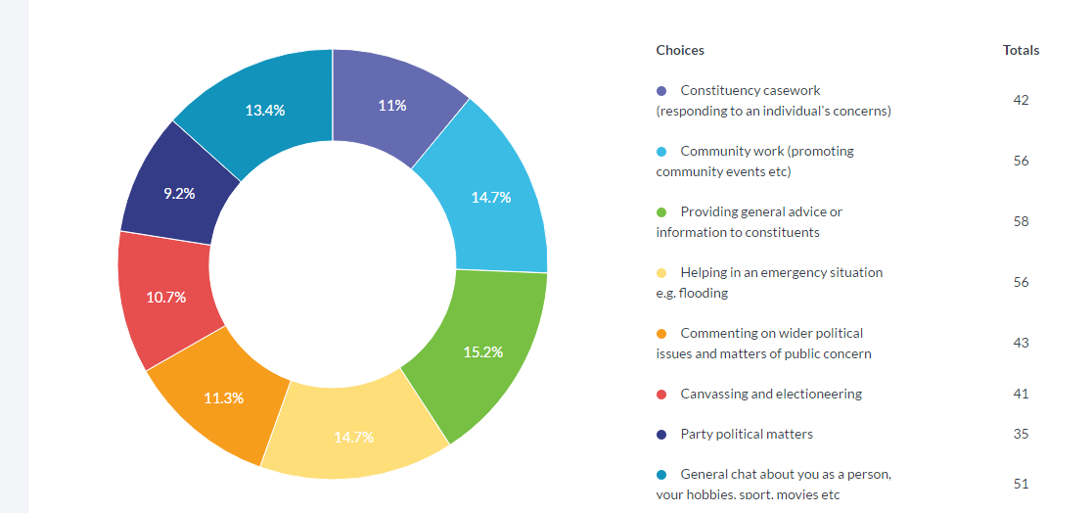

In total 68 participants answered this question, 7 participants did not answer this question.

Q.17 Which one of these activities do you most often use social media for (tick one box only)

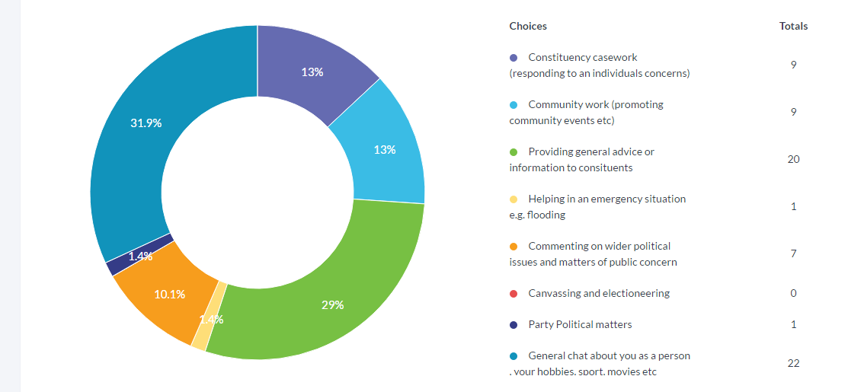

In total 69 participants answered this question, 6 participants did not answer this question.

Q.18 Do you have separate social media sites which you use only for your work as a Councillor?

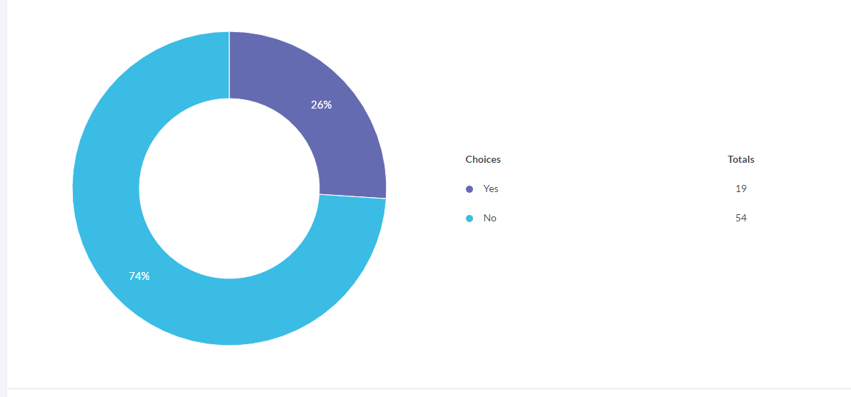

In total 73 participants answered this question, 2 participants did not answer this question.

Q.19 Do you know how to restrict access to the social media sites you use?

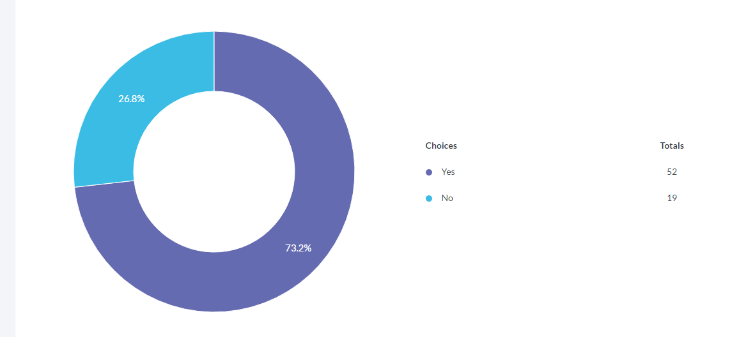

In total 71 participants answered this question, 4 participants did not answer this question.

Q20. If you have social media sites you use only in your private life, do you use any ‘privacy settings’ to restrict access to family / and or friends

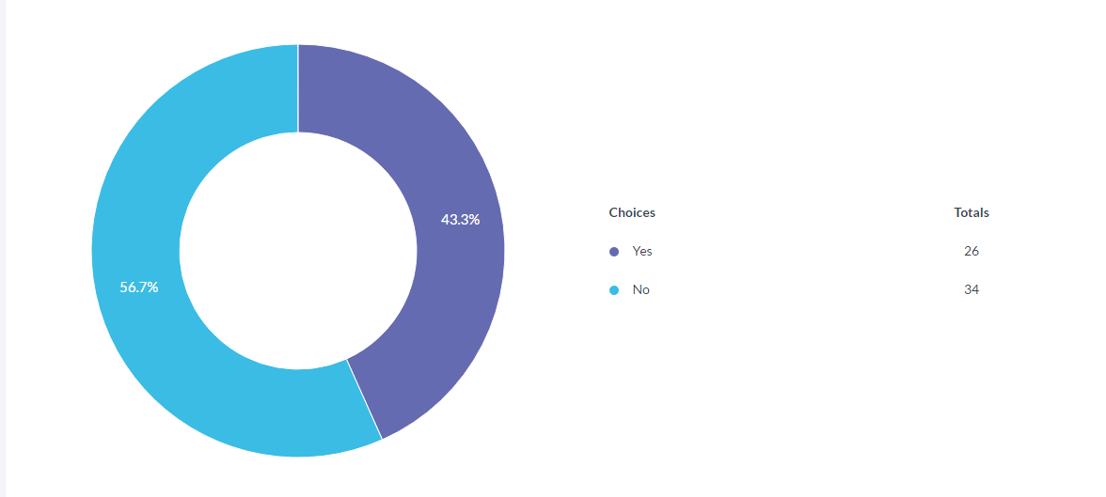

In total 60 participants answered this question, 15 participants did not answer this question.

Q21. Who updates your social media sites?
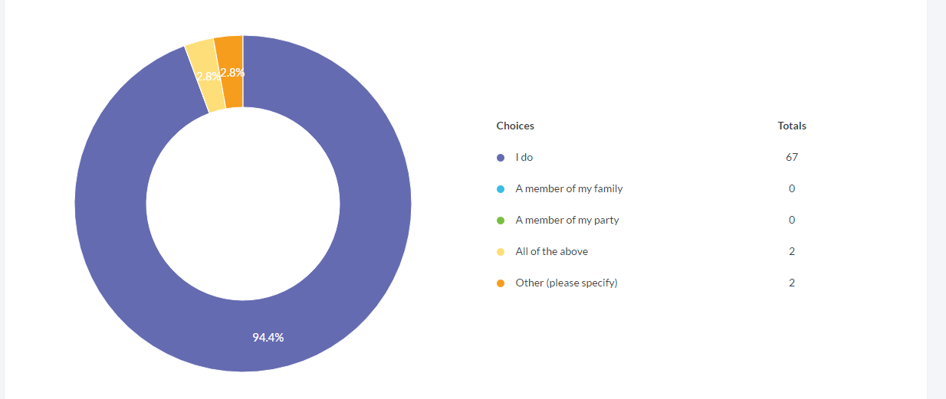
In total 71 participants answered this question, 4 participants did not answer this question.

